AN ASP-BASED APPROACH TO REPRESENTING AND QUERYING TEXTUAL KNOWLEDGE

by

Dhruva Rajan Pendharkar

APPROVED BY SUPERVISORY COMMITTEE:

___________________________________________

Dr. Gopal Gupta, Chair

___________________________________________

Dr. Vibhav Gogate, Co-Chair

___________________________________________

Dr. Vincent Ng, Co-Chair

Copyright © 2018

Dhruva Rajan Pendharkar

All Rights Reserved

Dedicated to my loving parents

AN ASP-BASED APPROACH TO REPRESENTING AND QUERYING TEXTUAL KNOWLEDGE

by

Dhruva RAJAN pendharkar, b.e.

THESIS

Presented to the Faculty of

The University of Texas at Dallas

in Partial Fulfillment

of the Requirements

for the Degree of

MASTER OF SCIENCE IN

COMPUTER SCIENCE

THE UNIVERSITY OF TEXAS AT DALLAS

May 2018

Acknowledgments

I would like to thank my advisor and professor Dr. Gopal Gupta for giving me an opportunity to work with him. It was because of his continuous guidance and support that I was able to complete my thesis. I would also like to thank Dr. Vincent Ng and Dr. Vibhav Gogate for helping me with resources and encouraging me by being on my supervisory committee.

The ALPS lab along with its members provided me with an ideal and a productive work environment. The group meetings really helped me shape my ideas and mold them into constructive work. I would also like to thank all my colleagues, Dr. Zhuo Chen, Farhad Shakerin, Elmer Salazar and Sarat Chandra Varanasi, for all the interesting brainstorming sessions and helpful suggestions.

I would like to thank my parents Rajan Pendharkar and Vinita Pendharkar for their encouragement and support towards my master’s education. Lastly, I am grateful to all my friends at the University without whom this ride wouldn’t have been so much fun.

May 2018

AN ASP-BASED APPROACH TO REPRESENTING AND QUERYING TEXTUAL KNOWLEDGE

Dhruva Rajan Pendharkar, M.S.

The University of Texas at Dallas, 2018

Abstract

Supervising Professor: Dr. Gopal Gupta

Knowledge Representation and Reasoning (KRnR) is a field of Artificial Intelligence that deals with converting information into knowledge patterns in a form that the computer understands. It applies concepts from the field of psychology, about how humans make rational decisions, to build formal rules that model the human cognitive processes. Using the generated knowledge bases the computer is then able to solve complex tasks like question answering, summarization, automated reasoning, medical diagnosis and many more. Many of these complex tasks, mentioned above, requires an understanding of natural language text.

A vast amount of knowledge that we have today comes from books and is in the form of natural language text. Such knowledge is in an unstructured form and is not easily interpretable by computers. Knowledge representation approaches try to convert this unstructured textual knowledge into a format that is meaningful to the computer, thus opening the doors for more knowledge sources.

In this thesis, I propose using an answer set programming (ASP) approach for knowledge generation from natural language text and reasoning using ASP-solvers like SaSP and clasp. Here, I have also explored different ways of modelling common sense reasoning using default logic patterns, hierarchical knowledge patterns and negation as failure. The thesis uses question answering as a task to represent the effectiveness of the generated knowledge from text. The proposed system consists of a query engine that accepts natural language questions and converts them into answer set queries automatically, which can be used by the solvers for question answering. To make the knowledge base richer in information and the querying engine more robust, we make use of knowledge resources like WordNet. This approach has been tested on the SQuAD dataset and has proved to be a promising proof of concept.

Table of Contents

ACKNOWLEDGMENTS ......................................................................................................... v ABSTRACT................................................................................................................................ vi LIST OF FIGURES .................................................................................................................... ix

LIST OF TABLES....................................................................................................................... x CHAPTER 1 INTRODUCTION.............................................................................................<pg#>

* 1. Overview...............................................................................................................<pg#>
  2. Related Work........................................................................................................<pg#>
  3. Contributions........................................................................................................<pg#>
  4. Structure of the Thesis..........................................................................................<pg#>

CHAPTER 2 ANSWER-SET PROGRAMMING..................................................................<pg#>

2.1 Overview...............................................................................................................<pg#>

2.2 What is Answer Set Programming (ASP) ............................................................<pg#>

2.3 Syntax....................................................................................................................<pg#>

2.4 Semantics...............................................................................................................<pg#>

2.5 Default Reasoning.................................................................................................<pg#>

CHAPTER 3 SYSTEM ARCHITECTURE...........................................................................<pg#>

3.1 Overview..............................................................................................................<pg#>

3.2 System Architecture.............................................................................................<pg#>

3.3 Common Resources Framework..........................................................................<pg#>

3.4 Knowledge Generation System............................................................................<pg#>

3.5 Query Generation System....................................................................................<pg#>

CHAPTER 4 SOFTWARE DEVELOPMENT APPROACH................................................<pg#>

CHAPTER 5 NATURAL LANGUAGE RESOURCES........................................................<pg#>

CHAPTER 6 KNOWLEDGE REPRESENTATION.............................................................<pg#>

CHAPTER 7 QUERY GENERATION..................................................................................<pg#>

CHAPTER 8 APPLICATIONS IN QUESTION ANSWERING...........................................<pg#>

CHAPTER 9 FUTURE WORK..............................................................................................<pg#>

CHAPTER 10 CONCLUSION...............................................................................................<pg#>

BIBLIOGRAPHY...................................................................................................................<pg#>BIOGRAPHICAL SKETCH.................................................................................................. <pg#> CURRICULUM VITAE

List of Figures

List of TABLES

# 

## INTRODUCTIOn

* 1. **Overview**

The goal of artificial intelligence is to build systems that act as humans. Decision making and the ability to reason are one of the important attributes of humans. Hence, machines possessing artificial intelligence must be capable of automated reasoning and acting according their changing environment. To exhibit such an intelligent behavior, a machine needs to understand its environment, its abilities to interact with the environment and its goals. For acting rationally, a machine must be able to obtain information and understand it. Thus, Automated reasoning and representation of information are important fields that lie at the intersection of computer science, formal logic, and philosophy.

For many years classical logic approaches were used to solve the problems of automated reasoning, but they did not work due to classical logic being undecidable, monotonic, and incomplete. Reasoning needed to be broken down into multiple components. This would make modelling with automated reasoning simpler. Humans in general use defaults, exceptions, and preference patterns while doing reasoning. Default rules are generic rules that can be applied to concepts. Such rules can sometimes have exceptions. As an example, we can have a default rule that says, “*All plants are green*”. This is true in most cases as ‘*Chlorophyll*’ is the prominent green pigment in most plants that makes them green. But there are some plants, that contain high quantities of red pigments or absence of chlorophyll, that are not green. Such instances of plants form exceptions to the default rule. Other important features of human reasoning are non-monotonicity, which states that humans can revise their conclusions in the light of newer information, and the ability to deal with incomplete information. Humans can easily make decisions or come to conclusions in the absence of data. All these properties of human reasoning need to be modelled in automated reasoning and require negation as failure. Answer set programming is one of the popular formalisms that exhibits non-monotonicity. Apart from that the ASP paradigm also includes both classical negation as well as negation as failure. It is applied to problems of planning, constraint satisfaction and optimizations and has well known implementations like clasp and DLV. Thus, ASP is well suited for modelling common-sense reasoning patterns.

Many of the fields of artificial intelligence lack structured resources. Most of the resources available today are in the form of unstructured data either in the form of written documents, or information present in the form of articles and paragraphs on websites like Wikipedia. Tasks that are being solved by computers like in the fields of Natural Language Processing would benefit from the availability of this information in the form of structured data. With the help of some event-calculus, ASP could prove to be a helpful paradigm to represent and reason from textual knowledge. Thus, in this thesis we propose a system to automatically convert textual knowledge into ASP programs and to be able to query the ASP program to get answers. Here we would also touch upon how we can model some of the common-sense reasoning patterns mentioned earlier to be able to reason better.

**1.2 Related Work**

Cyc is one of the oldest artificial intelligence project, that tries to collect information about basic concepts and about how the world works. This knowledge is presented in the form of a vast knowledge base or ontology that consists of implicit knowledge and rules about the world that we as humans call common sense knowledge. Such a project aimed at enabling AI applications to reason about their surroundings like a human and be able to handle failures gracefully. To build a project that could express common sense knowledge in the form of machine understandable code there needed to be a highly expressive representation language, developing a knowledge base using the language that would be used to infer from, developing a fast inference engine that would be able to reason like humans and would be able to handle human like complexity. The ontology of Cyc was about 100,000 terms till 1994 but then as of 2017 contains around 1,500,000 terms. This includes around 500,000 collections, 50,000+ predicates and around a million well known entities.

Cyc's language CycL made it efficient to represent common sense knowledge in the project and decided how this knowledge is represented in the project. To solve the problem of efficiently inferring from hundreds of millions of arguments Cyc used a community-of-agents architecture where it employed various types of reasoning agents call heuristic modules to solve the inference problem. Currently, Cyc uses more than 1000 heuristic models for inference. Much of the current work on Cyc includes knowledge engineering that includes representing facts about the world by hand and implementing inference techniques on that knowledge. Recently, Cycorp has planned to use Cyc's natural language processing to parse unstructured data like that presented by the documents on the internet to extract structured data.

The medical domain has always been one of the major focuses of expert knowledge-based systems. One of such applications based on chronic pulmonary disease or heart failure was modelled and built by Dr. Zhuo Chen under the guidance of Dr. Gopal Gupta. Its goal is to provide management of chronic illnesses like diabetes, cardiac and pulmonary diseases. One of the ways in which such diseases can be managed is by following a set of rules or guidelines laid out by experts in the domain. As most of these guidelines are highly complex and rely on many factors, physicians sometimes ignore them or fail to abide by them. This can adversely affect the patients’ health. Most of the problems come from the fact that these guidelines apart from being highly complex are also large in number making the task of recommendation prone to errors. This problem was tackled in the work with the help of answer set programming. The approach included creation of a set of knowledge pattern or rules that act as reasoning templates, which were used to model the guidelines provided by experts.

**1.3 Contributions**

The main contribution of this thesis is a proposal for efficiently converting textual knowledge into an ASP program. This includes defining a generic custom event calculus that helps to represent knowledge. Chapter 6 dives deeper into how a paragraph can be converted into a program. Other than that, the thesis touches on how knowledge sources like WordNet can be used to create an ontology. The ontology created is dynamic in nature and only deals with the concepts that occur in the input paragraph. This helps with not exploding the generated ASP program with rules that are not necessary. Such an ontology can be either generated every time if space is the issue or else it could be built to improve iteratively with increasing number of paragraphs in the system. WordNet concepts are always accompanied by their senses, so Chapter 6 also talks about how to apply a default preferential pattern for finding out the best sense of a given concept.

Apart from that, the thesis also proposes a framework for converting natural language questions into ASP queries. These queries can be provided to SAT solvers along with the ASP program to get answers. The query generation framework is being made robust with the help of a technique to relax constraints on the queries thus increasing the coverage of the question. Thus, the thesis converts the question answering task from a natural language passage to a constraint satisfaction problem, where the paragraph defines the problem environment and the question defines the constraints applied on the environment.

**1.4 Structure of the Thesis**

In this section, a layout of the remaining chapters is provided with a summary for each of them.

Chapter 2 mainly deals with Answer Set Programming. It describes the syntax of answer set programs and goes over the various ASP semantics used in the thesis. This chapter gives the background on answer set programming which is crucial for understanding the rest of the thesis

Chapter 3 introduces the architecture of the proposed system. It goes over the components of the system viz. Knowledge Generation, Query Generation, and the Common Resource Framework. It further discusses on how these components interact with each other to produce answer sets.

Chapter 4 discusses the Test-Driven Development approach that was used to build the system and create rules for knowledge generation. It goes through the various steps of a development cycle in TDD and explains its importance.

Chapter 5 provides information about the various Natural Language Resources used to support the system. This chapter covers the concepts required for understanding what these tools produce and how it can be used in later chapters.

Chapter 6 covers the various predicates that have been defined for the knowledge generation module. It explains their structure and what they represent. Apart from predicates generated from the passage it also talks about how information is extracted from WordNet by building an ontology.

Chapter 7 provides a method of automatic Query Generation from a natural language question. This chapter elaborates on how various queries can be generated automatically from a question and applies a confidence metric with each query that relates to the accuracy of the answer obtained from that query.

Chapter 8 describes how the above-mentioned system performs when applied to the task of Question Answering. Here, we introduce the SQuAD dataset by Stanford and how it is structured. This chapter states the results obtained from question answering and analyzes them.

Chapter 9 elaborates on a set of features or enhancements that can be made to improve the current system. It touches upon modelling temporal reasoning, cause effect reasoning and certain other common-sense reasoning patterns.

Finally, we draw some conclusions in Chapter 10. We summarize some of the salient points and review a few contributions of this thesis. This thesis also includes an Appendix at the end including all the references.

# 

## ANSWER-SET PROGRAMMING

**2.1 Overview**

The system that has been designed uses an ASP-based approach to represent knowledge from natural language text. So, a basic understanding of answer-set programming is required to understand the remainder of the thesis. This chapter introduces the answer-set programming paradigm and further elaborates on some of the important definitions, concepts and patterns used in answer-set programming.

**2.2 What is Answer-Set Programming (ASP)**

Answer-Set Programming is a declarative problem-solving paradigm that uses both non-monotonic reasoning and logic programming. It is widely used in automatically solving problems relating to representation and reasoning tasks such as modeling reasoning agents, non-monotonic inferences, common sense reasoning, modeling preferences and priorities and many more. An answer set program is a collection of statements that describe the objects of a domain and model relations between them. The semantics of an ASP Program defines a set of possible beliefs that an agent has associated with the program. This set of beliefs is called as an answer-set. The basic constituents of an ASP program are the rules, facts and constraints that describe the problem. Such a program is then passed onto an answer-set solver, which generates answer-sets to the program, that are used to obtain solutions to the problem.

**2.3 Syntax**

In this subsection, we introduce the syntax of an ASP program.

**2.3.1 Atom**

The most basic constituent of the ASP program is an atom. An atomic statement or an atom, is an expression of the form *p (t1,…, tn)* where *p* is a predicate symbol of arity *n* and *t1…tn* are n terms belonging to the predicate *p*. Here *n >= 0* and the terms *ti* can be integers or strings of letters, numbers, or underscore that either begin with an underscore or a lower-case letter. If in an atomic statement *n = 0*, then the brackets are omitted. As an example, ‘*parent (mary, alice)*’ and ‘*alice*’ are both atoms, whereas ‘*parent (mary, girl(alice))*’ is not an atom.

**2.3.2 Literal**

A literal is an atom of the form *p (t1,…, tn)* or its negation *-p (t1,…, tn)*. Here, *-p (t1,…, tn)* is referred to as a negative literal. It means that *p (t1,…, tn)* is false. An atom is called as a ground literal if every term *ti* in the atom is ground. For example, ‘*parent (X, Y)*’ is a literal whereas ‘*parent (mary, alice)*’ is called as a ground literal.

**2.3.3 Rule or Clause**

An ASP Program consists of a collection of rules of the form

1. l0
2. li 🡨 li+1, …, lm, not lm+1,…, not ln

Here, the symbol ‘not’ is a logical connective and is called as a default negation or negation as failure. Its semantic is discussed later in the chapter. An ASP rule is divided into two parts viz. head and a body. A head is a literal on the left side of the rule and a body is a set of literals on the right side of the rule. The head or the body in a rule can be empty. A rule with an empty head is called as a constraint whereas a rule with an empty body is called as a fact.

**2.4 Semantics**

Using the earlier mentioned syntax, we create an ASP program as a collection of rules, facts, and constraints. In this section, we shall discuss about the meaning of these rules and how they are interpreted while reasoning using these rules. The following are a few semantic patterns commonly used in answer-set programs.

**2.4.1 Modelling Implication**

As we saw earlier, every rule (excluding facts) in ASP has two parts separated by the consequence operator “:-”. In such a rule the head of the rule is said to succeed only if every literal in the body of the rule succeeds. As an example, consider the rule

*p :- q, r.*

we can read this kind of rule as “if *q* and *r* succeed then *p* succeeds”. Such kind of a pattern is commonly used in ASP programs to show implications.

**2.4.2 Classical Negation**

Classical Negation is a pattern in which we use negative literals, to show the fact that the literal under consideration has been proved to be false. As an example, consider the following rule.

*-p(a) :- q(a)*

The above rule states that if *q(a)* is shown to succeed then *p(a)* is false or *-p(a)* is true. Classical negation is one of the ways to represent negations in ASP programs.

**2.4.3 Epistemic Disjunction**

We model epistemic disjunctions in ASP when we need to model the semantics for the statement, “Either *p(a)* succeeds or *q(a)* succeeds”. Epistemic disjunction is different from exclusive or, where both *p(a)* and *q(a)* might succeed at the same time. Thus, to model epistemic disjunction we can make use of even loops in the following manner.

*p(a) :- not q(a).*

*q(a) :- not p(a).*

If we solve the above ASP program using an answer-set solver we will get two answer sets {*p(a)*} and {*q(a)*}, i.e. either *p(a)* succeeds or *q(a)* succeeds.

**2.4.4 Constraints**

Constraints are applied in places where we know that certain rules are always false and should not be part of the answer-set. As an example, if we know that it is impossible for *p(a)* to succeed then we can model this constraint as follows

*:- p(a).*

The above rule states that *p(a)* is always false. Here we see that a constraint limits the sets of beliefs that an agent has but does not help to derive new information.

**2.4.5 Default Negation or Negation as Failure (NAF)**

Default Negation, also called as Negation as Failure is used to make conclusions based on the absence of information. This type of negation is used to conclude about default rules and assume defaults to be true in case of absence of enough information. As an example, consider the following example where we state that if we are not able to prove that *q(a)* succeeds then *p(a)* succeeds.

*p(a) :- not q(a).*

So, in the above rule we assumed that *p(a)* has succeeded based on the absence of information about *q(a)*. NAF is an important tool to model defaults in ASP programs. Negation as Failure assumes closed-world assumption (CWA), in which we assume, what is not currently known to be true, as false.

**2.5 Default Reasoning**

Default Reasoning or Representing Defaults is one of the advantages of using ASP. The concept of closed-world assumption discussed earlier is an example of default reasoning where we default the value of the literal to fail in the absence of the literal in the answer set. Default reasoning is very useful in modelling human reasoning as we can draw conclusions even in the absence of information by defaulting to the default rule. Default reasoning thus plays an important role in common sense reasoning and understanding. In case of ASP, a default d stated as “Normally elements of class C have property P” is represented as the following rule

*p(X) :- c(X),*

*not ab(d(X)),*

*not -p(X).*

Here, *ab(d(X))* can be read as “X is abnormal with respect to the default assumption d” and *not-p(X)* can be read as “We can’t successfully prove that *p(X)* is false” or “*p(X)* may be true”.

Default reasoning uses two kinds of exceptions viz Strong exceptions and weak exceptions. Weak exception makes the default inapplicable and stop the agent from making a default conclusion. For example, in the above-mentioned default rule we can apply a weak exception *e(X)* by adding the following rule to the program

*ab(d(X)) :- not -e(X).*

The exception states that X may not be applicable to d if *e(X)* may be true. Similarly, Strong Exceptions refute the defaults conclusion by allowing the agent to derive the opposite to be true. This can be demonstrated by adding the following rule to the program

*-p(X) :- e(X).*

The above rule states that *p(X)* is false if *e(X)* succeeds, which allows us to defeat d’s conclusion that normally class C elements have the property P.

## SYSTEM ARCHITECTURE

**3.1 Overview**

This chapter mainly focuses on the various parts of the system and how they interact with each other. It also describes the various sub-components and modules used in generating the knowledge base and goes through the various steps required to answer queries with the help of the generated ASP program.

**3.2 System Architecture**

The system is composed of two main components or sub systems viz. the Knowledge Generation System and the Query Generation System. Both these systems function independent of each other. The architecture comprises of a common resource framework that is shared by both these systems. This chapter will describe all these components in detail in the rest of the chapter.

**3.2.1 Components of the System**

As illustrated in the figure, the Knowledge Generation System, the Query Generation System, and the Common Resource Framework are the three components of the architecture. The Common Resource Framework consists of Natural Language Processing tools such as Stanford Core NLP Tools, WordNet API as well as modules for preprocessing incoming text. The Knowledge Generation System is mainly responsible for extracting knowledge from a natural language text. For extracting the knowledge from text, this component uses Stanford NLP tools like the POS Tagger, Stanford Dependency Parser, and the Stanford NER Tagger to gain more information about the input text.

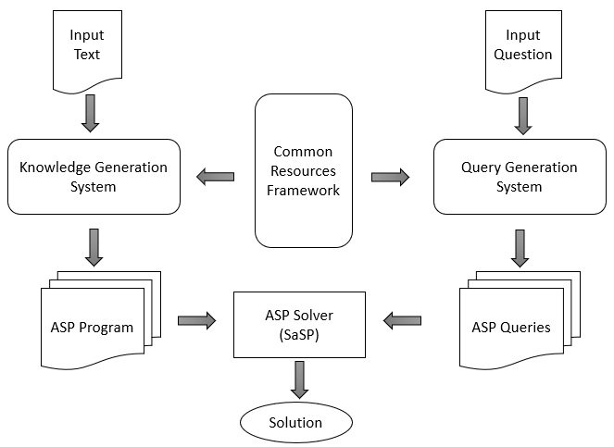

Apart from these resources it also taps into the vast information that is provided by WordNet and tries to extract information from the same. As currently there are a very few digital resources about verbs in the NLP domain, this component provides a flexible way to add custom information about verbs that would be reusable in many scenarios. Thus, the Knowledge Generation System takes in the natural language passage as input and produces rules in the form of three chunks of information, which can be aggregated together to form an ASP program representing all the extractable knowledge from the source text.

To help answer questions posed in Natural Language, the Query Generation System is used to automatically generate a set of queries that can be used to find solutions from the answer-sets generated by the ASP program. To ask queries to the ASP program we need to provide both the queries as well as the ASP program to an Answer-Set Solver like SaSP or Clasp. The Query Generation System generates multiple queries for a question and arranges them in the order of significance, keeping the more constraint queries before the less constraint ones. Hence, the kind of query that would lead to an answer is also a rough metric as to the quality of the answer. Now let’s dive deep into the various components in the architecture and talk about its sub modules and their interactions.

**3.3 Common Resources Framework**

The Common Resources Framework consists of the following modules as illustrated in the diagram.

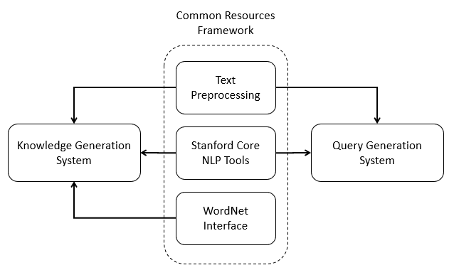

**3.3.1 Text Preprocessing Module**

The style of writing in natural language text changes based on the domain, author, title of the text and many other factors. To automate text processing, becomes a very hard task when we must consider all these different writing styles. Thus, for this system we assume certain properties about the incoming natural language text. The text pre-processing module is the first module that the input text passes through and it makes sure that the input text conforms to these assumptions. Some of the assumptions that we make about the incoming text include concatenation of compound nouns and resolution of coreferences. National Aeronautics and Space Administration or NASA is an excellent example of a compound noun. In this example, we assume that the system detects and treats NASA to be a single concept (National_Aeronautics_and_Space_Administration) as opposed to separate words. Coreference resolution is the task of finding all expressions that refer to the same entity in a text. It plays an important role in higher level NLP tasks and so we assume that the coreferences in the incoming text have already been resolved. Many a times due to informal writing styles, humans miss certain words or assume certain words while reading and writing texts. Working with such informal style of English is hard, so we assume that the incoming text is written in formal English. As this system depends on many NLP tools for semantic resources, it is susceptible to any flaws in these tools. The preprocessing module tries to correct any mis-tagged entries in the text, due to ambiguous wording, with the help of relations given by higher level semantic tools.

**3.3.2 Stanford NLP Core Tools**

Stanford Core NLP Tools is a set of linguistic tools that help in analyzing and understanding natural language text. It consists of a lot of different sub tools that can be pipelined one after the other to analyze a piece of text. It provides solutions to NLP tasks like POS Tagging, Parsing, NER Tagging, Coreference resolution and many more that play a vital role in higher level NLP tasks like text understanding. This system uses the Stanford-Core-NLP version 3.9.1 on the Java Platform and makes extensive use of its POS Tagger, NER Tagger, Stanford Dependency Parsing, and some other tools on the framework to process incoming text.

**3.3.3 WordNet Interface**

One of the important things in text understanding is being able to extract more information about concepts in the passage. This helps the system gain a deeper understanding into a concept. WordNet is one such digital resource that helps in gaining more knowledge about a concept. WordNet is a large lexical database of English. It consists of a large number of concepts grouped into sets of words that are synonyms i.e. synsets. WordNet has thus created a huge network of concepts by linking these synsets based on lexical relations and conceptual-semantics. WordNet's structure makes it a useful tool for computational linguistics and natural language processing. Java WordNet Interface or JWI is a Java library for interfacing with Wordnet created at MIT. With the help of JWI this system interfaces with WordNet and extracts semantic relations like hypernyms, hyponyms, meronyms etc. to gain more information on the passage.

**3.4 Knowledge Generation System**

The Knowledge Generation System deals with the generation of rules from text and extracting information from other sources like WordNet. This system is made up of 3 modules which are described as follows

**3.4.1 Knowledge Extraction from Text**

This module is responsible for generating rules and facts from the passage itself. It uses the various rules and patterns mentioned in Chapter 7 to generate part of the ASP program. The ASP rules generated by this module should contain all the information present in the input passage. The input file that is supplied to this module is assumed to be preprocessed according to the earlier mentioned assumptions.

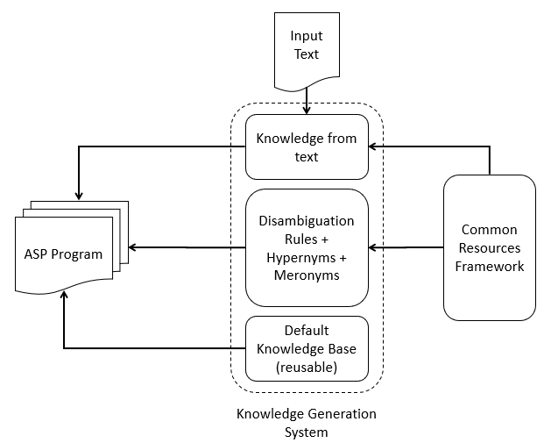

**3.4.2 WordNet Ontology Generation**

To further understand the concepts mentioned in the input passage, the ontology generation module generates rules regarding disambiguation, hypernyms, and meronyms. Word sense disambiguation forms an integral part of NLP and is also tackled by this module using default reasoning. The Hypernym relation and the Meronym relation along with other relations like Antonyms and Synonyms help capture more semantic information into the ASP program. These topics would be touched upon in detail in the forthcoming chapters.

**3.4.3 Default Knowledge Base**

As mentioned earlier, there is very little digitalized information about the semantics of verbs in the NLP domain. Hence, to gain complete understanding of verbs and their usage, it is required to create rules, describing their complete meaning, manually. The default knowledge base makes it feasible to add knowledge about verbs and nouns by hand. Care must be taken to make sure that the knowledge being added is generic in nature and is reusable for other similar scenarios. With the help of such an increasing knowledge base the system can become more efficient and accurate.

**3.5 Query Generation System**

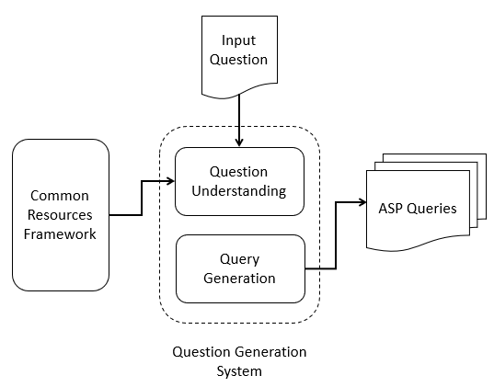

The Query Generation System is responsible for understanding the question asked in natural language text and converting it into a set of ranked queries, that could be understood by the ASP Solver to answer the question. It is comprised of the following 2 modules.

**3.5.1 Query Understanding**

Questions asked in natural language can be classified into multiple types based on various theories. To classify a question into a specific type requires complete understanding of the question along with the type of answer expected by the question. This module is tasked at finding the various components of the question including the kind of question, based on the ‘Wh’ word and the lexical type and kind of answer expected.

**3.5.2 Query Generation**

Using the information provided by the query understanding module, the query generation module first creates the most constraint query applicable for the question under consideration. This module then starts relaxing certain constraints in the query giving rise to lower quality queries or queries with lower confidence. In the later chapters, we discuss this approach in detail.

## CHAPTER TITLE

## CHAPTER TITLE

## CHAPTER TITLE

## CHAPTER TITLE

## CHAPTER TITLE

## CHAPTER TITLE

## CHAPTER TITLE

**ReFERENCES (OR Bibliography)**

**Biographical sketch**

**CURRICULUM Vitae**